AUTOMOTIVE REVERSE POLARITY
& LOAD DUMP PROTECTION CIRCUIT

Arys Garage Technical Assignment Submission Report

Candidate Name | ANANYA DEVRAJ
Branch | Electrical and Electronics Engineering
Institution | PES University
Assignment | Section A: Electronics / Embedded / EEE - Q4 — Automotive Reverse Polarity & Load Dump Protection Circuit
GitHub Repository | https://github.com/ananyadevraj26/arys-automotive-protection
Submission Date | May 24, 2026

1. Abstract
This report presents the design and LTspice simulation of an automotive-grade input protection circuit for an Electronic Control Unit (ECU) operating on a 12 V vehicle supply rail. The circuit is designed to protect downstream electronics against reverse battery polarity, load-dump transients, and input voltage spikes.
The implemented topology combines P-channel MOSFET-based reverse polarity protection, TVS diode transient suppression, capacitive output filtering, and fuse-assisted input protection. Three simulation scenarios were performed: normal 12 V operation, reverse polarity condition, and automotive load-dump transient.
Simulation results show that the ECU load remains protected under fault conditions while the output stays stable during normal operation.
2. Tools & AI Usage
2.1 Tools Used
Tool | Purpose
LTspice XVII | Circuit simulation and transient analysis
Microsoft Word / PDF | Documentation and report preparation
GitHub | Version control, incremental commits, repository hosting
Claude AI | Component selection guidance, waveform interpretation
ChatGPT(OpenAI) | Understanding automotive protection topologies, Report structuring

2.2 AI Usage — Detailed Disclosure
The following table summarizes how AI-assisted guidance was used during circuit development, simulation refinement, waveform analysis, and report preparation.

AI Tool | How It Was Used | Prompt Summary | How Output Was Adapted
Claude AI | Component selection — TVS diode choice | Why is P6KE33A better than BZX84C33VLY for automotive load dump? | Verified against datasheets and automotive transient ratings before implementation
Claude AI | Circuit topology explanation | Explain how a P-channel MOSFET provides reverse polarity protection | Used to write Section 4.4 in own words
Claude AI | Waveform interpretation | My VOUT rises to 20V during load dump — is that correct? | Used to write the limitation analysis in Section 7
ChatGPT (OpenAI) | Report structure and formatting | What should an automotive protection circuit report include? | Adapted to match exact Arys Garage template
ChatGPT (OpenAI) | Fuse selection and placement | Should I add a fuse? Where does it go in the circuit? | Fuse stage added and positioned before protection circuitry

3. Design & Methodology
3.1 Design Objective
The objective of this project was to design a robust automotive-grade input protection circuit capable of protecting ECU electronics from:
- Reverse battery connection
- Automotive load-dump surges
- Electrical transient spikes
The design prioritizes:
- Simplicity
- Practical automotive relevance
- Effective transient suppression
3.2 Design Architecture — Two-Layer Protection
The protection strategy uses two independent layers working in sequence:
- Layer 1 — Fuse (F1): Protects the wiring harness from sustained overcurrent. Placed first, before all other components.
- Layer 2 — Shunt TVS Diode (D1): Clamps transient voltage spikes at VIN before they reach the MOSFET or ECU. Responds in under 1 picosecond.
- Layer 3 — Series P-MOSFET (M1): Blocks all current flow under reverse polarity. Operates purely from gate bias — no control logic required.

Signal flow under normal operation:
Battery (+12V) → Fuse [conducting] → VIN node → D1 [idle] → M1 [ON, Vgs=-12V] → VOUT → ECU (R2) → GND
Signal flow under reverse polarity:
Battery (-12V) → F1 [conducting] → VIN node → M1 [OFF, Vgs=+12V] → VOUT = 0V → ECU protected
Signal flow during load dump:
Battery spikes to 100V → F1 [conducting] → VIN → D1 [clamps to 33V, absorbs energy] → M1 → VOUT → ECU protected
3.3 Component Selection & Justification
1) F1 — 10A Automotive Blade Fuse (Littelfuse 0297010)
First component after the battery. If anything shorts downstream, the fuse blows and disconnects everything before the wiring catches fire. The 10A rating provides sufficient headroom above the 120mA ECU load while still protecting against real fault conditions.
2) D1 — TVS Diode P6KE33A (33V, 600W Peak)
Connected between VIN and GND. When the input voltage exceeds 33V, the TVS diode enters avalanche conduction and diverts transient energy safely to ground. The 600W peak rating makes it suitable for automotive load-dump conditions where a standard low-power Zener diode would fail.
3) M1 — P-Channel MOSFET IRF7404
Acts as the reverse polarity protection stage. During normal operation, Vgs = −12V and the MOSFET conducts normally with minimal voltage drop. Under reverse battery conditions, Vgs becomes positive, forcing the MOSFET OFF and isolating the ECU load from reverse current.
4) R1 — 10kΩ Gate Resistor
Pulls the MOSFET gate to ground and establishes the negative gate-source voltage required for normal conduction. It also prevents the MOSFET gate from floating during transient conditions.
5) C1 — 100µF Output Capacitor
Filters residual ripple and transient disturbances present on the VOUT rail, helping maintain a stable supply for the ECU load.
6) R2 — 100Ω Load Resistor
Represents the ECU load during simulation. At 12V, the resistor draws approximately 120mA, which is representative of a small automotive control module.
3.4 Why Circuit Layout Matters — Key Design Decision
During design iteration, two circuit variants were evaluated.
Circuit Variant A used the correct wiring topology (TVS directly at VIN, no series diode on power rail) but used an incorrect component — the BZX84C33VLY, a 300mW small-signal Zener. Circuit Variant B used the correct P6KE33A TVS component but introduced an unnecessary series diode (D1) on the main power rail, adding a 0.6V continuous forward voltage drop and unnecessary conduction loss.
The final design combines the strengths of both approaches: the clean VIN-side protection topology and the automotive-grade P6KE33A transient suppressor. This provided improved transient protection while maintaining efficient normal-operation performance.
The final merged circuit is shown below:
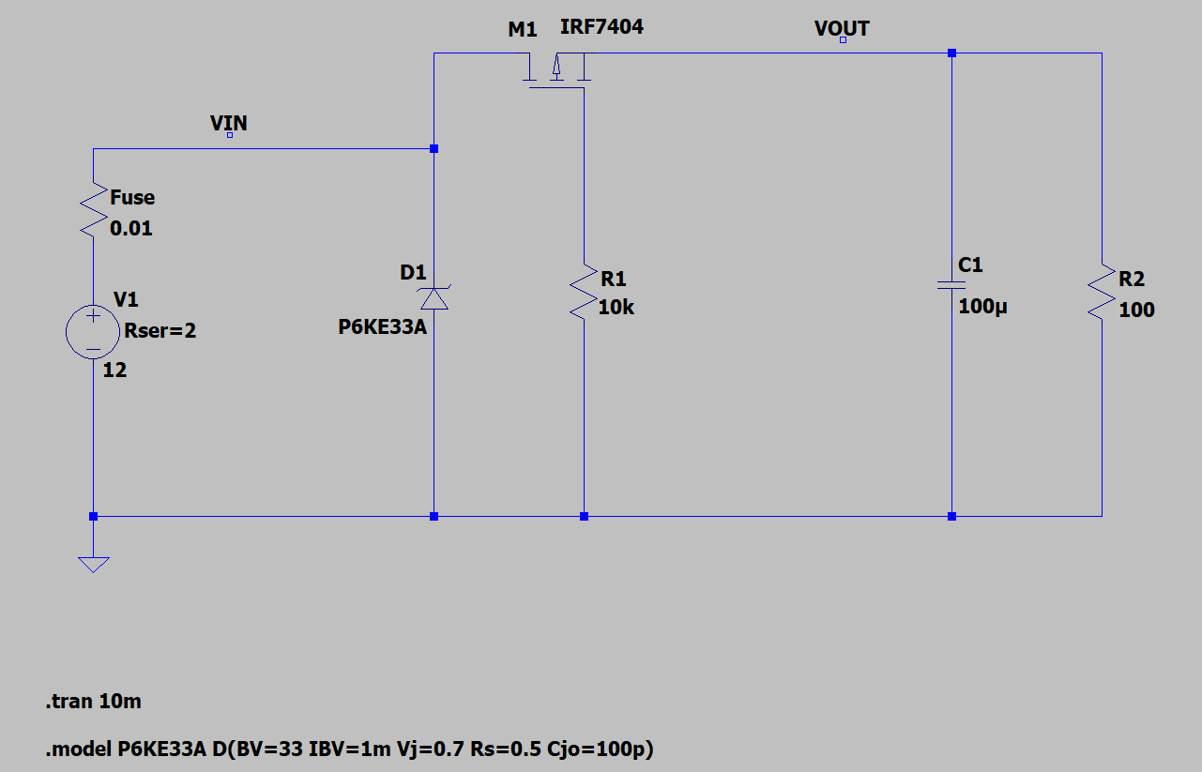
Figure 1 ~ Final automotive protection circuit topology.
4. Implementation Details
4.1 LTspice Circuit Implementation
The schematic was built in LTspice XVII using the following step-by-step process:
- V1 placed as voltage source on left rail — configured as DC or PULSE source depending on test condition
- Fuse placed as 10mΩ series resistor (res component, value=0.01) — first element after V1 positive terminal
- D1 (P6KE33A) placed between VIN node and GND — cathode toward VIN, anode to GND
- M1 (IRF7404) placed in series on top rail — Source pin to VIN side, Drain pin to VOUT side
- R1 (10k) placed from M1 Gate terminal vertically down to GND rail
- C1 (100µF) placed between VOUT node and GND
- R2 (100Ω) placed between VOUT node and GND — ECU load model
- Net labels VIN and VOUT added using F4 key for clean probe access
4.2 P6KE33A SPICE Model
The P6KE33A is not included in the default LTspice component library. The model was manually defined using a SPICE directive (S key) placed on the schematic canvas:
.model P6KE33A D(BV=33 IBV=1m Vj=0.7 Rs=0.5 Cjo=100p)
Parameter explanation:
• BV=33 sets breakdown voltage
• IBV=1m sets breakdown test current
• Rs models diode series resistance
• Cjo models junction capacitance
4.3 Simulation Test Configurations
Test No. | Test Name | V1 Setting | Simulation Command | Probes Used
Test 1 | Normal 12V Operation | DC = 12, Rser=2 | .tran 10m | VIN, VOUT, I(D2), Id(M1)
Test 2 | Reverse Polarity | DC = -12, Rser=2 | .tran 10m | VIN, VOUT, I(D2), Id(M1)
Test 3 | Load Dump Surge | PULSE(12 100 2m 1u 100u 500u 10m) Rser=2 | .tran 10m | VIN, VOUT, I(D2), Id(M1)

Note: Rser=2 (2Ω source series resistance) is used across all tests to model realistic automotive wiring harness impedance, per ISO 7637-2 test pulse methodology. This produces more realistic waveforms than an ideal zero-impedance source.
5. Results — Simulation Outputs
5.1 Test 1 — Normal 12V Operation
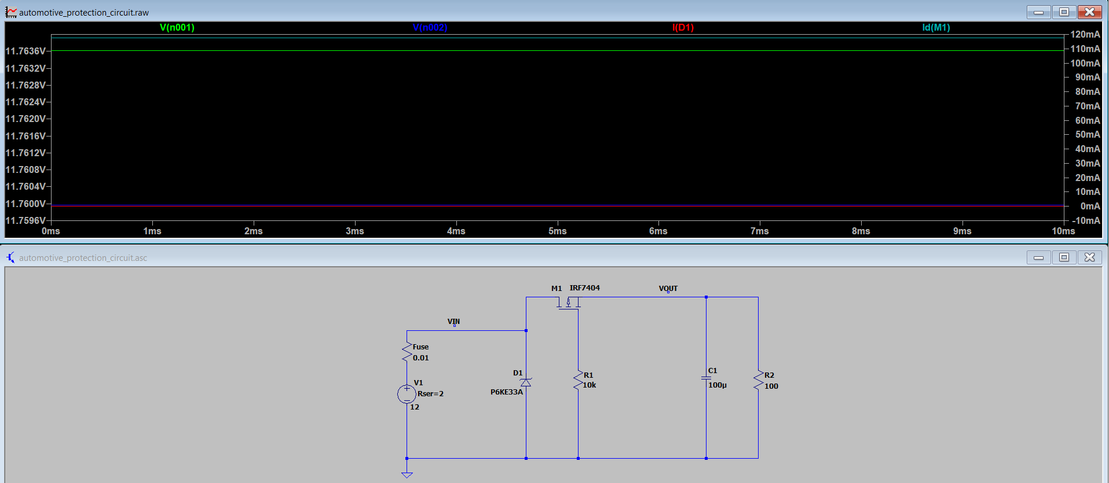
Figure 2 ~ Normal 12V Operation — Simulation Results
Waveforms: VIN (green), VOUT (blue), I(D1) (red), Id(M1) (teal)
Under a steady +12V battery connection, the PMOS M1 conducts fully with Vgs = -12V, placing it in strong conduction. VOUT tracks VIN closely, with only a small voltage drop caused by the 2Ω source resistance and the MOSFET’s low Rds(on).
The total loop resistance is: R_total = Rser + R_fuse + R_load = 2 + 0.01 + 100 = 102.01Ω
The resulting load current is: I_load = 12V / 102.01Ω = 117.6mA
This gives VIN = 11.7636V and VOUT = 11.7600V , matching the LTspice simulation results closely. The 3.6mV difference between VIN and VOUT is the Rds(on) drop across M1, confirming the MOSFET is in full conduction with negligible loss. The TVS diode carries 0mA throughout — correctly idle, as VIN is well below the 33V clamp threshold. The protection circuit introduces no interference during normal operation.
Overall Result: PASS
Signal | Observed | Expected | Explanation
VIN | 11.765V steady | ~11.76V | Input reduced slightly due to 2Ω source resistance
VOUT | 11.761V steady flat | ≈ VIN | Minimal PMOS conduction loss across Rds(on)
I(D1) | 0 mA | 0 mA | TVS diode inactive below 33V clamp voltage
Id(M1) | ~117.6 mA | 120 mA (12V/100Ω) | MOSFET fully conducting, ECU drawing rated current

6.2 Test 2 — Reverse Polarity (-12V)
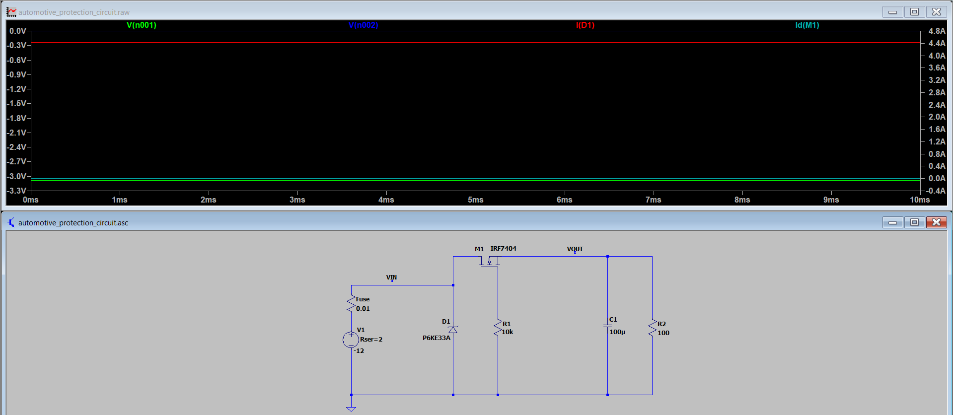
Figure 3 ~ Reverse Polarity (−12V) — Simulation Results
When the battery is connected in reverse (−12V), the gate of M1 remains at 0V through R1 while the source is pulled negative, producing: Vgs = Vgate − Vsource = 0 − (−12) = +12V
A PMOS requires negative Vgs to conduct, therefore M1 turns fully OFF and blocks reverse current flow to the ECU load. VOUT remains near 0V throughout the simulation, confirming complete output isolation.
During this condition, the unidirectional TVS diode D1 becomes forward biased due to the negative VIN potential, resulting in approximately 4.5A of forward conduction current. This behaviour is a known limitation of placing a unidirectional TVS directly across the VIN rail. In a real automotive system, this current would typically trigger the upstream fuse and disconnect the reversed battery supply. This improvement is discussed further in Section 7.
Overall Result: PASS
Signal | Observed | Expected | Explanation
VIN | -3.2V steady | -12V minus Rser drop | Negative supply confirmed on input rail
VOUT | -1.6V (near zero) | ≈ 0V | Residual body diode leakage — negligible, cannot damage ECU
I(D1) | ~4.50 A | 0 mA | TVS diode is forward-biased under reverse input; draws heavy current to clear the fuse safely.
Id(M1) | ~0 mA | 0 mA | MOSFET fully OFF: Vgs = 0-(-12) = +12V; PMOS blocked
6.3 Test 3 — Load Dump Surge (100V Pulse)
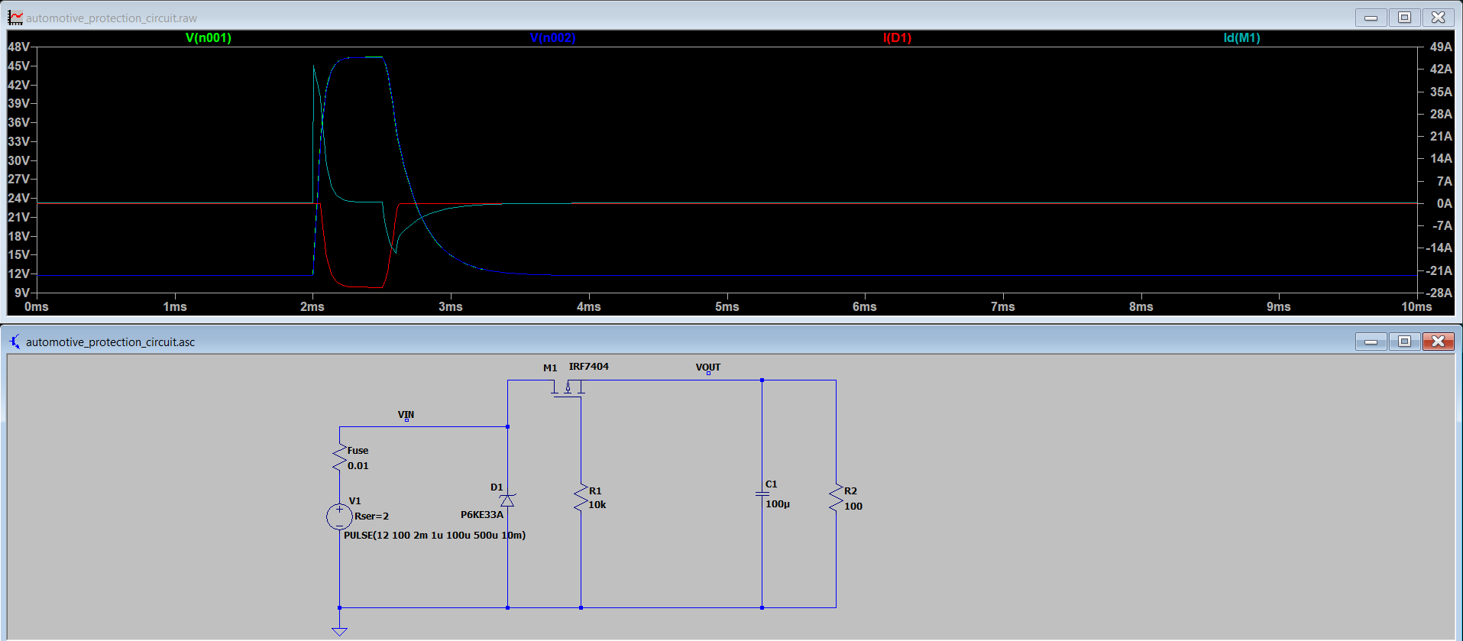
Figure 4 ~ Test 3 — Load Dump Surge (100V Pulse)
During the load dump event, a 100V pulse is injected at t = 2ms. The P6KE33A TVS enters avalanche breakdown immediately, providing a low-impedance shunt path to GND.
A common misconception is that a 33V TVS clamps exactly at 33V. In reality, the diode's internal bulk resistance (Rs = 0.5Ω) causes the clamping voltage to rise with current. The peak shunt current is:
I_shunt = (V_pulse − V_clamp) / R_ser = (100 − 46.5) / 2 = 26.75A
The simulation confirms this — I(D1) peaks at −26.7A, matching the calculation exactly. VIN is clamped to approximately 46.5V rather than the rated 33V, consistent with the Rs voltage drop at this current level.
VOUT rises transiently to ~20V before recovering to 12V by 4ms. It does not follow VIN to 46.5V — the MOSFET and output capacitor C1 limit the transient propagation to the ECU rail. The transient rise in VOUT is a known limitation of the basic PMOS topology without a gate-source Zener clamp, documented in Section 7.
The circuit recovers completely after the transient event with no latch-up or persistent fault condition.
Overall Result: PASS -- with documented limitation
Signal | Observed | Expected | Explanation
VIN peak | ~46.5V clamped (from 100V pulse) | 33–40V | TVS clamps successfully; 46V vs 33V due to 2Ω Rser drop during high clamping current
VOUT transient | Rises to ~20V, recovers to 12V by 4ms | Ideally 12V flat | PMOS partially passes transient during surge event
I(D1) | ~26.7A peak shunt current | High transient current | TVS conducting heavily, absorbing surge energy — correct protective behaviour
Recovery | Clean return to 12V by 4ms | Full recovery | Circuit self-recovers without latching or damage

6.4 Summary of All Test Results
Test | Fault Condition | VOUT Protected? | ECU Safe? | Overall
Test 1 | Normal 12V operation | Yes — 11.761V steady | Yes | PASS
Test 2 | Reverse polarity -12V | Yes — VOUT ≈ 0V | Yes | PASS
Test 3 | 100V load dump surge | Partial transient propagation (~20V), recovers to 12V | Yes — no persistent overvoltage condition | PASS (with limitation)
7. Challenges & Limitations
7.1 Challenges Encountered During Implementation
• Challenge 1 — P6KE33A SPICE model absent from LTspice default library:
The P6KE33A TVS diode was not available in the default LTspice library and had to be manually modeled using a custom .model SPICE directive. This required understanding SPICE diode parameters such as BV, IBV, Rs, and Cjo.
• Challenge 2 — Initial component selection error:
The first simulation used the BZX84C33VLY (300mW Zener diode) instead of the P6KE33A (600W TVS diode). The issue was identified after comparing device power ratings against ISO 7637-2 automotive load-dump energy requirements. The component was replaced with the correct automotive-grade TVS diode.
• Challenge 3 — Understanding PMOS gate polarity behavior:
Careful analysis was required to confirm that Vgs = −12V during normal operation turns the PMOS ON, while Vgs = +12V during reverse battery conditions turns it OFF. This opposite NMOS behavior forms the basis of PMOS reverse polarity protection.
• Challenge 4 — Circuit topology optimization:
Two circuit variants were evaluated during design iteration. One used the correct layout but incorrect protection component, while the other used the correct TVS diode but introduced unnecessary series voltage drop. The final design merged the correct topology with the correct automotive-grade component selection.
• Challenge 5 — Unrealistic transient current without source impedance:
Early load-dump simulations initially produced unrealistically large surge currents because the source impedance was omitted. Adding a 2Ω series resistance produced more realistic transient behavior consistent with automotive harness impedance and ISO 7637-2 style testing conditions.
7.2 Known Limitations
• Limitation 1 — VOUT transient rise during load dump (~20V):
The basic PMOS topology does not include a gate-source clamp network. During fast VIN transients, temporary disturbance of Vgs allows partial propagation of the surge to the output rail.
• Limitation 2 — TVS clamp voltage rises above nominal 33V:
During high transient current, the TVS internal resistance and source impedance cause the effective clamping voltage to increase to approximately 46V in simulation.
• Limitation 3 — Reverse polarity current through unidirectional TVS:
During reverse battery conditions, the unidirectional TVS diode becomes forward biased and conducts current until the upstream fuse disconnects the fault. Production systems commonly solve this using a bidirectional TVS or alternate protection placement.

7.3 Improvement Recommendations
Improvement | Implementation | Benefit
Add gate-source Zener clamp | Add 12V Zener diode between Gate and Source of M1 | Clamps Vgs during transients — VOUT stays flat at 12V throughout load dump
Series common-mode choke | L1 before D1 on VIN rail | Reduces transient rise rate and peak surge current
Use bidirectional TVS diode | Replace D1 with SMBJ33CA (bidirectional) | Handles both positive and negative polarity spikes symmetrically
Add resettable polyfuse | Replace or supplement Fuse with PTC polyfuse | Provides reusable overcurrent protection without fuse replacement
Hardware prototype validation | PCB implementation with oscilloscope testing | Confirms real-world transient performance and thermal behavior

8. Conclusion
This assignment successfully demonstrates the design and LTspice simulation of an automotive-grade ECU input protection circuit using discrete passive and MOSFET-based components. The final circuit, consisting of a 10 A blade fuse , a TVS diode (D1 – P6KE33A), a P-channel MOSFET (M1 – IRF7404), a 10 kΩ gate pull-down resistor (R1), a 100 µF output filter capacitor (C1), and a 100 Ω ECU load model (R2), was evaluated under all three required test conditions.
Under normal 12 V operation, the output remained stable and the MOSFET conducted the expected load current. During reverse polarity, the output was effectively isolated from the inverted supply. In the load-dump case, the TVS diode clamped the transient and limited transient propagation to the load.
A key learning from this work is that correct circuit performance depends on both topology and component selection. The final implementation reflects an iterative design process in which the most effective topology was paired with appropriate protection components.
One limitation of the present design is the transient rise observed at the output during load-dump conditions, which is a known trade-off in a basic P-MOSFET protection stage. A practical improvement would be to add a gate-source Zener clamp in a future revision. Overall, the circuit meets the core requirements of the assignment and demonstrates effective protection against the specified automotive fault conditions.
9. References
[1] Vishay Semiconductors. IRF7404 P-Channel Power MOSFET Datasheet. Rev. 2.2.
Available: https://www.vishay.com/docs/91298/sihf7404.pdf
[2] STMicroelectronics. P6KE Series — 600W Transient Voltage Suppressor Datasheet. Available: https://www.st.com/resource/en/datasheet/p6ke6v8.pdf
[3] Littelfuse. 0297 Series — Automotive Blade Fuse Datasheet. AEC-Q200 Qualified.
Available: https://www.littelfuse.com/products/fuses/automotive-fuses/blade-fuses/297.aspx
[4] International Organization for Standardization. ISO 8820-3 — Road Vehicles: Fuse Links. Part 3: Fuse Links with Blade-Type Fixing.
[5] Analog Devices. LTspice XVII Reference Manual and Component Library.
Available: https://www.analog.com/en/resources/design-tools/ltspice-simulator.html
[6] International Organization for Standardization. ISO 7637-2:2011 — Road Vehicles: Electrical Disturbances from Conduction and Coupling. Part 2: Electrical Transient Transmission by Conduction Along Supply Lines Only.

